Neural Networks & Deep Learning: ICP1

**Name: Dheeraj Kodakandla**

**Student Id: 700738796**

**Video Link:**

[**https://drive.google.com/file/d/1RIT_t0YiIiKOsqAhnO5W3P6ODyYqBCLE/view?usp=sharing**](https://drive.google.com/file/d/1RIT_t0YiIiKOsqAhnO5W3P6ODyYqBCLE/view?usp=sharing)

**GitHub Link: https://github.com/dheeraj3119/Assignment_1.git**

1. Implement Naïve Bayes method using scikit-learn library. Use dataset available with name glass.

Use train_test_split to create the training and testing part. Evaluate the model on test part using score and classification_report(y_true, y_pred)

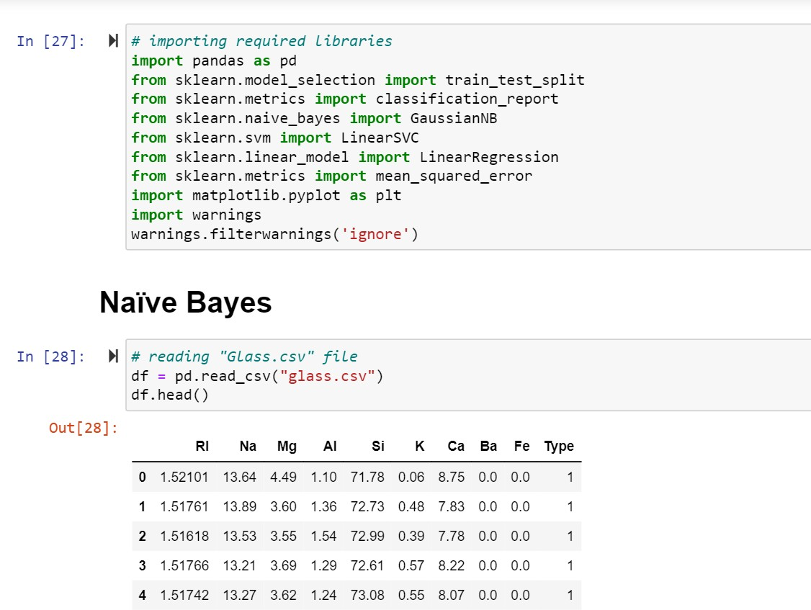

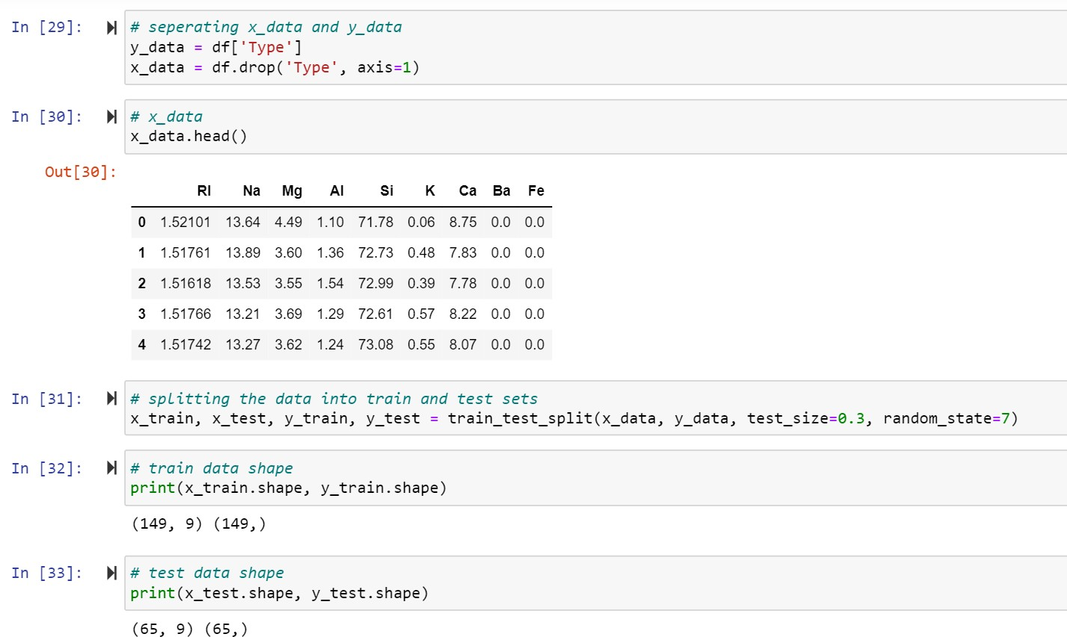

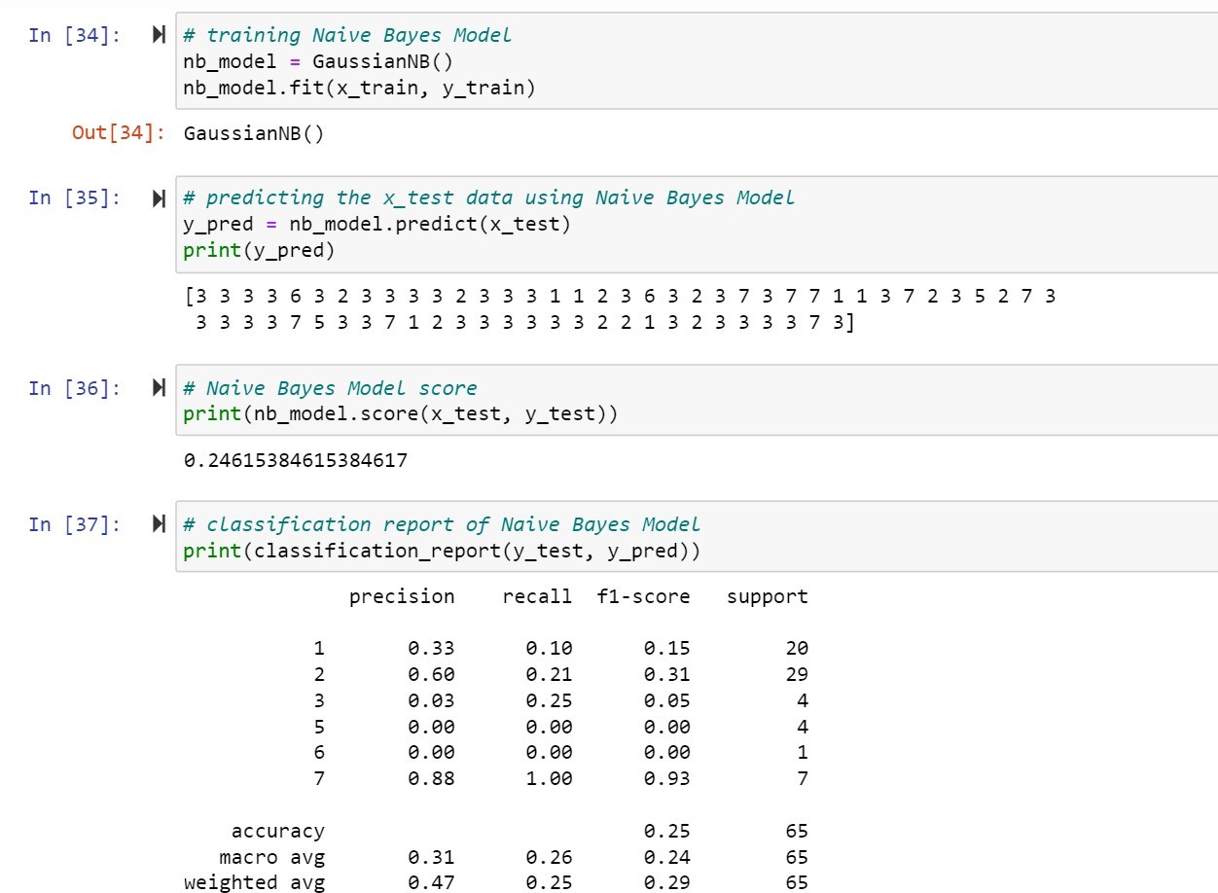

1. Implement linear SVM method using scikit-learn. Use the same dataset above.

Use train_test_split to create training and testing part. Evaluate the model on test part using score and classification_report(y_true, y_pred)

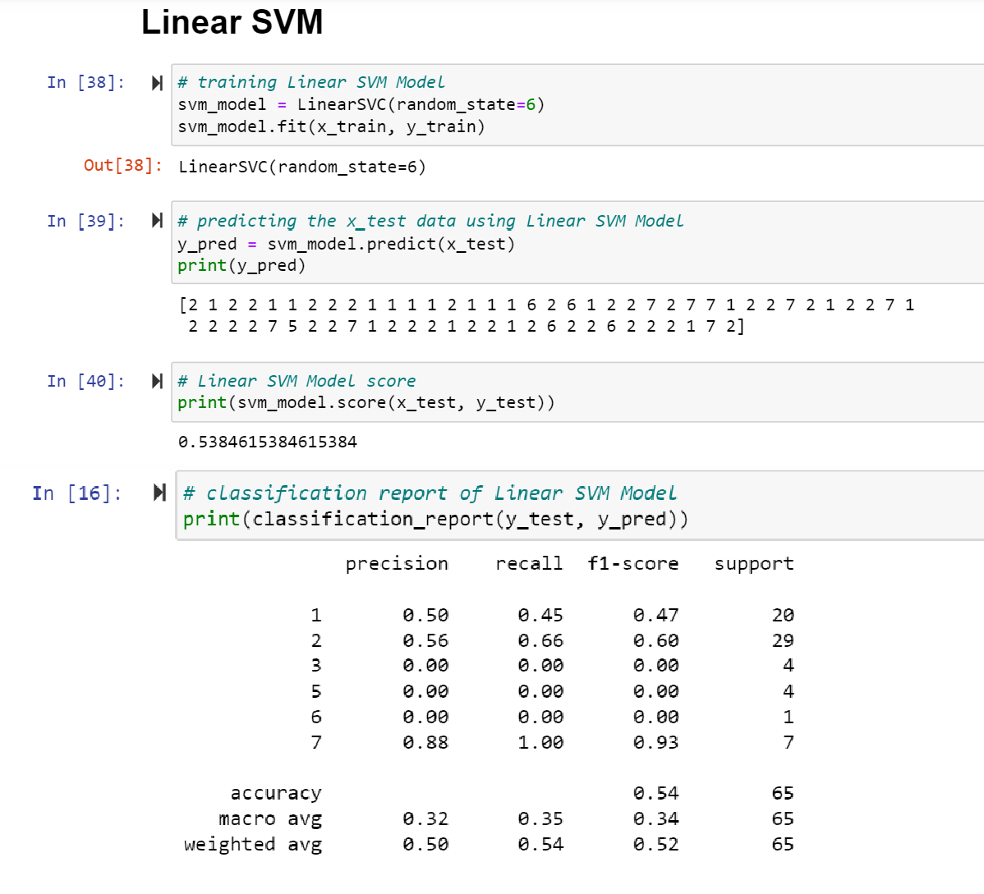

Which algorithm you got better accuracy? Can you justify why?

Linear SVM has better accuracy than Naive Bayes Model because SVM can perform well in classifying multi-dimensional data and since Naive Bayes is based upon the frequency of occurrence it was not able to classify data.

1. Implement Linear Regression using scikit-learn
2. Import the given “Salary_Data.csv”
3. Split the data in train_test partitions, such that 1/3 of the data is reserved as test subset.
4. Train and predict the model.
5. Calculate the mean_squared error.
6. Visualize both train and test data using scatter plot.

